**EMAIL TEMPLATE: Campaign Kick-off**

**From:** Company CEO, Leader, or Employee Campaign Chair’s first and last name

**Audience:** All company employees

**Call to Action**: Donate now – the campaign is launched!

**Image**: Use below, or select one of your own images

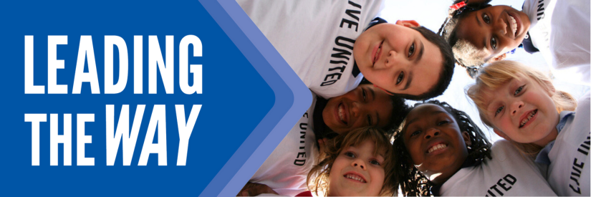   
  
**Subject Line**: YOU can impact lives  
**Preheader Text:** Build a thriving community – give to United Way  
**Email Body:**

Hello All,

[Company Name’s] United Way Campaign has officially launched! Everyone deserves to be a part of a thriving community. This year, our goal is to raise [$________]. When you donate to our campaign, you are leading the way for transformational change in Greater New Haven.

Together, we’re increasing access to food and stable housing, advancing the well-being of children, promoting economic mobility, and working towards a better future for all. Last year alone, your donations helped United Way served almost 100,000 people in our community.

At [Company Name], we are committed to building a community where everyone has the opportunity to thrive. Your donation to United Way changes lives for real local people, like the children in the picture below, who were able to get free math tutoring through a program led by United Way.

Please consider participating [INSERT LINK]. There are many ways to give – one of the easiest is through payroll deduction, which allows you to give a little at a time. No gift is too small.

Thank you,

[YOUR NAME HERE]

**EMAIL TEMPLATE: CEO Message**

**From:** Company CEO, Leader, or Employee Campaign Chair’s first and last name

**Audience:** All company employees

**Call to Action**: Give now to join the campaign

**Image**: Use below, or select one of your own images

**Subject Line:** [Company Name] is Leading the Way  
**Preheader Text:** In our community, everyone deserves the opportunity to thrive.  
**Email Body:**

**“The greatness of a community is most accurately measured by the compassionate actions of its members.”** – Coretta Scott King

[Name],

Everyone deserves to be a part of a thriving community. United Way of Greater New Haven supports the needs of our community every day to help strengthen our community. *Join me in leading the way for our community by participating in this year’s campaign.* We’ve set an ambitious goal of raising *[monetary goal/description*]to help do just that.

I believe that when we come together as a team, there’s no challenge that can’t be solved. That’s why I’m inviting you to join me in Leading the Way toward positive change in Greater New Haven. This is more than a campaign – it is a call to action for us at [Company Name] to advance solutions to real problems facing people in the communities where we live and work.

Together, we’re increasing access to food and stable housing, advancing the well-being of children, promoting economic mobility, and working towards a better future for all. We’re counting on generous people like you and your teammates to help improve the lives of people in our community. Last year, with our support, United Way of Greater New Haven was able to impact nearly 100,000 lives. And this year, with your help, we know that we can do even more.

[*Insert information about how they can donate]*

**BUTTON TEXT:** LEAD THE WAY [Hyperlink]

**EMAIL TEMPLATE: Mid-Campaign Push**

**From:** Company CEO, Leader, or Employee Campaign Chair’s first and last name

**Audience:** All company employees

**Call to Action**: Now is the time to make your donation!

**Image**: Use below, or select one of your own images

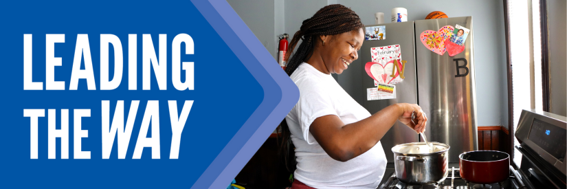   
  
**Subject Line:** You helped Shontaya find a place to call home  
**Preheader Text:** Your donations helped this mom give her kids a safe stable home.  
**Email Body:**

Every neighbor should have nutritious food and stable affordable housing.

But with rising costs of food, rent, and child care, more families in our community are struggling to afford the basics.

When you donate to United Way of Greater New Haven, you help local families access healthy food and find and keep safe housing.

Because of donors like you, United Way connects thousands of people to stable, affordable housing and feeds tens of thousands of our neighbors.

When New Haven resident Shontaya and her children found themselves with nowhere to stay after their apartment was condemned due to a landlord that didn’t keep up with maintenance, she called 2-1-1 and United Way helped connect her to a shelter, and eventually an affordable apartment that was a good fit for her and her kids.

**“I just want to see my kids every day happy. Now that we have the new apartment, we come home and they are so happy. I feel real good. I feel like okay, I did something, I did this.”**

Donate to [Company Name’s] United Way campaign and help neighbors like Shontaya overcome the challenges and build a thriving life.

**BUTTON TEXT:** HELP FAMILIES THRIVE [Hyperlink]

**EMAIL TEMPLATE: LAST PUSH**

**From:** Company CEO, Leader, or Employee Campaign Chair’s first and last name

**Audience:** All company employees

**Call to Action**: Last chance! Make your donation to our United Way campaign

**Image**: Use below, or select one of your own images

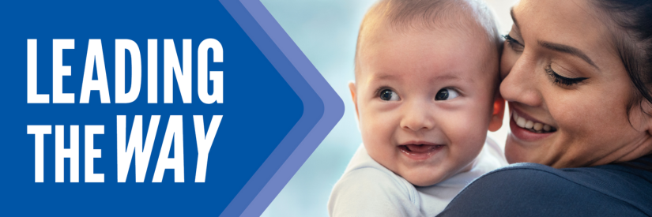   
  
**Subject Line:** Time is running out to Lead the Way

**Preheader Text:** Tick, tock…

**Email Body:**

Have you donated yet to [Company Name’s] United Way campaign?

Donate today and lead the way to help our neighbors access food, stable housing, childcare and education, and the resources to build economic mobility.

Employees at [Company Name] are chipping in and Leading the Way to a better future for everyone in Greater New Haven.

**BUTTON TEXT:** Donate [Hyperlink]

Thank you for your continued support!

[Name],

[Closing],  
*Signature*

**EMAIL TEMPLATE: THANK YOU**

**From:** Company CEO, Leader, or Employee Campaign Chair’s first and last name

**Audience:** All company employees

**Call to Action**: Thank you for donating!

**Image**: Use below, or select one of your own images

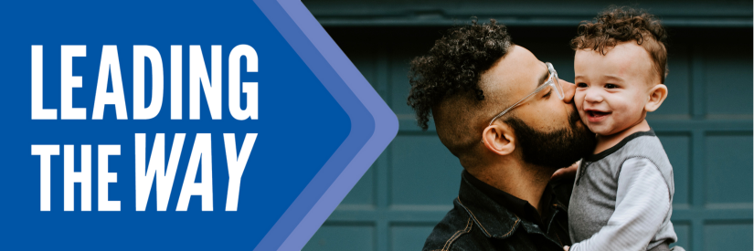   
  
**Subject Line:** Thank you for Leading the Way  
**Preheader Text:** (intentionally left blank)  
**Email Body:**

Dear [Donor Name],

Thank you for participating in our United Way campaign. Together, we are leading the way to a thriving community. Your donation to United Way will be put to work meeting critical needs for children, families, and neighbors in our community.

Thank you so much, not just from me or [Company Name], but from the countless lives you have impacted with your generosity.

Sincerely,

[YOUR NAME HERE]

P.S. See your impact – join United Way’s email list, follow them on social media, or join in a volunteer event! [https://linkin.bio/uwgnh]