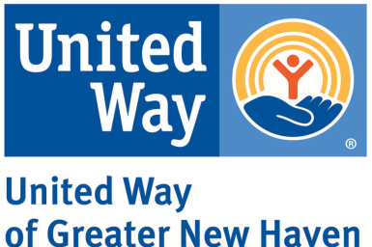

Thriving Families 2024 Application Working Document
The following document is intended to assist applicants in drafting a response to United Way of Greater New Haven’s 2024 Thriving Families Request for Proposals. Applications must be officially, electronically submitted through this link.
Agency Information
Agency Name:
Grant Contact Information:
- First & Last Name:
- Job Title:
- Email Address:
- Phone Number:
Executive Director Name:
Executive Director Email:
Address of organization’s primary place of business:
Regional Service Area: Identify the city(ies) and town(s) where the services will be provided (check all that apply)
- Bethany, Branford, East Haven, Guilford, Hamden, Madison, New Haven, North Branford, North Haven, Orange, West Haven, Woodbridge
Agency Structure & Capacity
- Please describe your agency’s mission and experience in successfully implementing workforce programming
Program Design and Outcomes
Please describe the following details for the program that the proposal is looking to enhance
- What population is the program intending to serve? What efforts are in place to recruit and serve job seekers from underserved communities?
- What services does the program provide directly and what services does the program refer out to?
- What type of job(s)/sector(s) is the program connecting job seekers to?
- What strategies do you have in place to partner with employers?
- How does the program and organization incorporate client voice and feedback into program design and continuous improvement?
- Please describe the specific program outcomes, the targets set for each, and how the program tracks progress and the required reporting measurements (Required reporting elements will include numbers served, participant demographics (city/town of residence, age, gender, race and ethnicity), what services they received or participated in, number exited from program, number employed, wage of employment, and sector of employment)
- If you are a previous Thriving Families grantee, please include outcomes achieved during the most recent grant year. If not, please write ‘N/A’
Use of Funds
- Which phase(s) will the requested funds support? (Check all that apply)
- Recruitment of underserved communities
- Retainment of job seekers in your program and/or
- Placement of job seekers in employment
- For each phase selected in the previous question (if selected more than one) describe how funds will be spent and what outcomes you expect to achieve if you received the requested funds from this grant
Commitments to Equity and Collaboration
- Please tell us how your agency demonstrates a commitment to advancing diversity, equity, and inclusion
- UWGNH is also committed to building effective collaboration between and across service providers. Describe how your organization collaborates with other agencies- in providing services, referrals, advocacy, participation in collaborative groups, or in other ways
Financial Capacity and Budget
- Describe how the agency will ensure allocated funds are tracked and used in accordance with the grant?
- What is your organization’s total annual budget?
Organizations will also be required to submit a budget breakdown of the proposed use of funds, including line items for personnel, direct, and administrative expenses using the template provided on the UWGNH website

