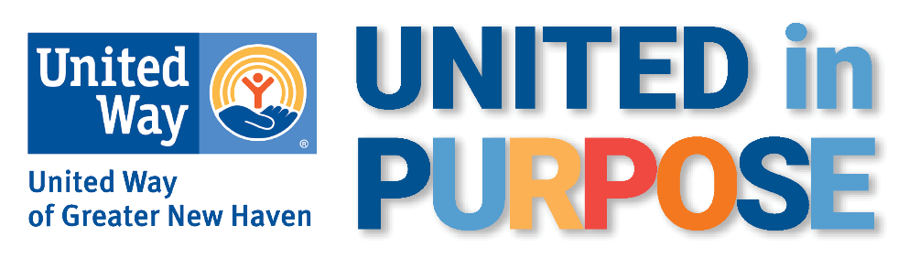

CAMPAIGN KICKOFF- SEND AT THE START OF THE CAMPAIGN

Subject Line: Live with Purpose – give to United Way!

Body Copy:

Hello All,

<<Company’s>> United Way Campaign has officially launched! Now is the time to put our shared values into action to uplift our neighbors. Together, we can work to close gaps and open opportunities for everyone.

Your donation makes a real difference for real families. We can help everyone thrive by improving access to education, food, stable housing, and opportunities to build financial stability. Last year alone, donors like you helped over 145,000 people in Greater New Haven.

At [COMPANY NAME HERE] we are committed to improving the quality of lives for people in our community. You can take action to put critical resources in the hands of neighbors.

Please consider participating [INSERT LINK]. There are many ways to give – one of the easiest is through payroll deduction, which allows you to give a little at a time. No gift is too small.
We’ve set a goal of raising [GOAL AMOUNT] and I know we can do it!

Thank you,
[YOUR NAME HERE]

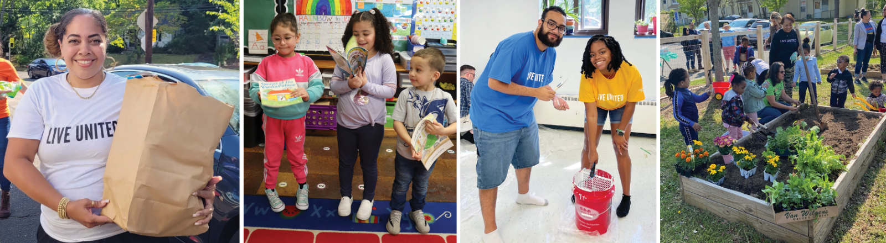

CAMPAIGN PREVIEW- SEND ONE WEEK BEFORE THE START OF THE CAMPAIGN

Subject Line: It’s time to LIVE UNITED!
Preview Text: Let’s get united and help our community

Body Copy:

Dear Colleagues,

I’m excited to share that our annual United Way campaign is just around the corner! Our campaign will launch on <<date>> and we have set a goal this year to raise <<insert goal>>. When we come together, we can accomplish big things, and I have every confidence that we can achieve our goal!

Your donation to United Way will be put to work meeting critical needs for children, parents, and neighbors in our community. Your support will give children quality child care and education, neighbors access to nutritious food and stable affordable housing, and families the resources to build a stable financial foundation.
Together, we have already made transformative changes in the lives of hundreds of thousands of people in our community. Donations of all sizes matter and will help our neighbors in need.

I’ll be sharing more in the weeks ahead about how donors like you are changing lives through United Way.

If you have questions, please do not hesitate to reach out.

Thank you for Living United,
[YOUR NAME HERE]

P.S. See how you helped impact 147,776 lives in the 2023 Impact Report!

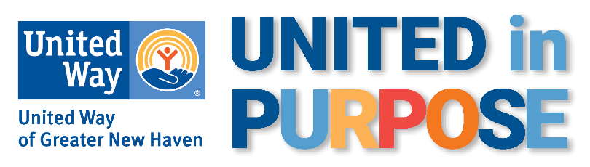

CEO MESSAGE:
SEND TOWARD THE BEGINNING OF THE CAMPAIGN

Subject Line: Give now and help children, families, and neighbors thrive!

Body Copy:
“Great things are done by a series of small things brought together.”
– Vincent Van Gough
Good afternoon,

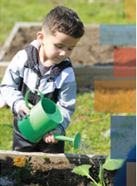Our United Way campaign is a way to join together in a common purpose and uplift our neighbors. Each of us can make a difference, but together we can make lasting change. Together, we can help make sure every child, every family, and every neighbor have the opportunities and resources to thrive.

We know that small acts can add up to a big impact. Through the generous support of donors like you, United Way of Greater New Haven was able to impact 147,776 lives last year alone.

We are united in our shared values and know that every donation makes a real difference for real people in our community. Every child can learn, grow, and thrive with quality childcare and education. Every family deserves stable financial foundations that allow them to achieve their goals and build better lives. Every neighbor should have nutritious food and stable affordable housing.

When we join together, we tackle even the most difficult challenges. Will you join me in making a donation? When you give to United Way, whether it’s one dollar, or at the highest levels of the Leadership and Tocqueville Societies, you’re changing lives.

To give today, visit [INSERT LINK] or see [INSERT NAME] to make your donation.

Thank you in advance for your generosity.

Sincerely,
[CEO NAME]

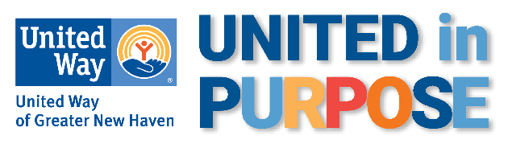

CAMPAIGN LAST PUSH
SEND TOWARD THE END OF THE CAMPAIGN

Subject Line: There is still time to join!
Preview text: Because of your support, Monique’s children have a stable place to call home

Body Copy:

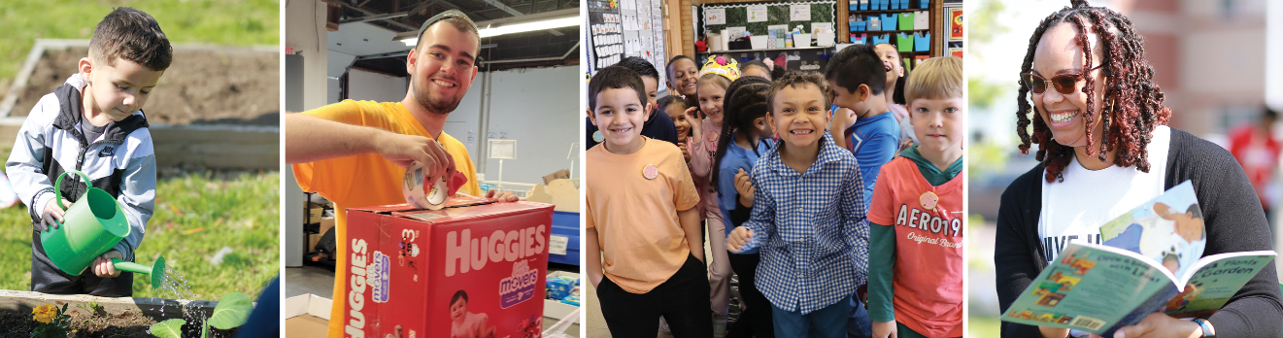

Because of donors like you, United Way was able to help Monique and her four children navigate a housing crisis and get back into a stable home. Monique is a New Haven resident who works full-time. She lost her housing when her rent increased by 30%. She and her kids were staying in a hotel room, but her savings were running out and they had nowhere else to go. She was eating only one meal a day in order to make sure that her kids had enough to eat.

Thanks to the support of donors like you, United Way was able to help Monique’s family recover from their housing crisis. United Way gave them funding to continue to stay in the hotel when their savings ran out and helped Monique with the search for a safe and affordable new apartment. United Way also helped provide funding to cover the upfront costs needed to move into a new apartment.

Monique reached out to United Way staff and shared her gratitude: "It's been a month now that we have been in our new place. I will never forget what you have done for my family. Thank you so much. You help families like mine in a horrible situation believe that things will be ok. You all have patience and understand and fight for us. I could not have done any of this alone."

United Way’s assistance made a world of difference for Monique and her children, but it wouldn’t be possible without the generosity of donors who help fund this critical work. Give now at [LINK] to help more local families access the resources they need to grow and thrive. You can make a world of difference for a child, parent, or neighbor.

CAMPAIGN PREVIEW- SEND ONE WEEK BEFORE THE START OF THE CAMPAIGN

Subject Line: It’s time to LIVE UNITED!
Preview Text: Let’s get united and help our community

Body Copy:

Dear Colleagues,

I’m excited to share that our annual United Way campaign is just around the corner! Our campaign will launch on <<date>> and we have set a goal this year to raise <<insert goal>>. When we come together, we can accomplish big things, and I have every confidence that we can achieve our goal!

Your donation to United Way will be put to work meeting critical needs for children, parents, and neighbors in our community. Your support will give children quality child care and education, neighbors access to nutritious food and stable affordable housing, and families the resources to build a stable financial foundation.
Together, we have already made transformative changes in the lives of hundreds of thousands of people in our community. Donations of all sizes matter and will help our neighbors in need.

I’ll be sharing more in the weeks ahead about how donors like you are changing lives through United Way.

If you have questions, please do not hesitate to reach out.

Thank you for Living United,
[YOUR NAME HERE]

P.S. See how you helped impact 147,776 lives in the 2023 Impact Report!

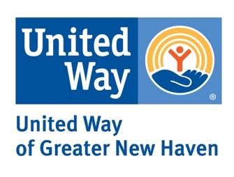

THANK YOU

SEND TO PEOPLE WHO HAVE MADE A GIFT

Subject Line: Thank You! Your gift changes lives
Preview Text: You help people like mom Emerald and her daughter Alayna

Body Copy:

Dear [NAME],

Thank you for participating in our United Way campaign and putting your values into action in our community. Your donation to United Way will be put to work meeting critical needs for children, parents, and neighbors in our community. You are offering people the resources they need to overcome obstacles and build a stronger future for themselves and their children.

“Anytime you want to achieve something, you have to surround yourself with people that care about you, that have your best interests at heart, who want to see you do well. You need positivity. United Way was that support network for me.”
- Emerald, Early Head Start mom and Workforce Alliance trainee

Thank you so much, not just from me or [COMPANY NAME], but from the countless lives you have impacted with your generosity.

Sincerely,
[YOUR NAME HERE]

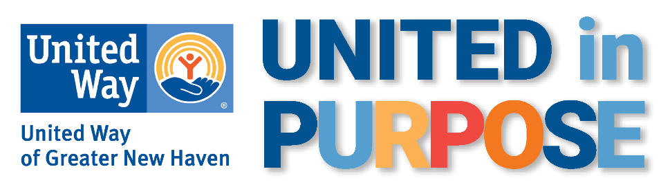

THANK YOU
SEND TO PEOPLE WHO HAVE MADE A GIFT
Subject Line: Thank You! Your gift changes lives.
Preview Text: Your donation uplifts our neighbors.

Body Copy:
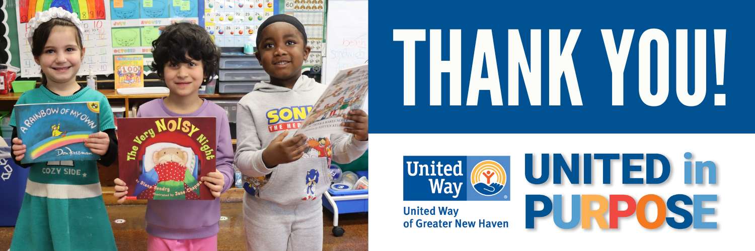

Dear [NAME],
Thank you for participating in our United Way campaign. Together, we are putting our shared values into action to uplift our neighbors. Your donation to United Way will be put to work meeting critical needs for children, families, and neighbors in our community. We know improving access to education, food, stable housing, and financial stability can help all thrive.
Thank you so much, not just from me or [COMPANY NAME], but from the countless lives you have impacted with your generosity. Each of us can make a difference, but together we can make lasting change.
Sincerely,
[YOUR NAME HERE]

