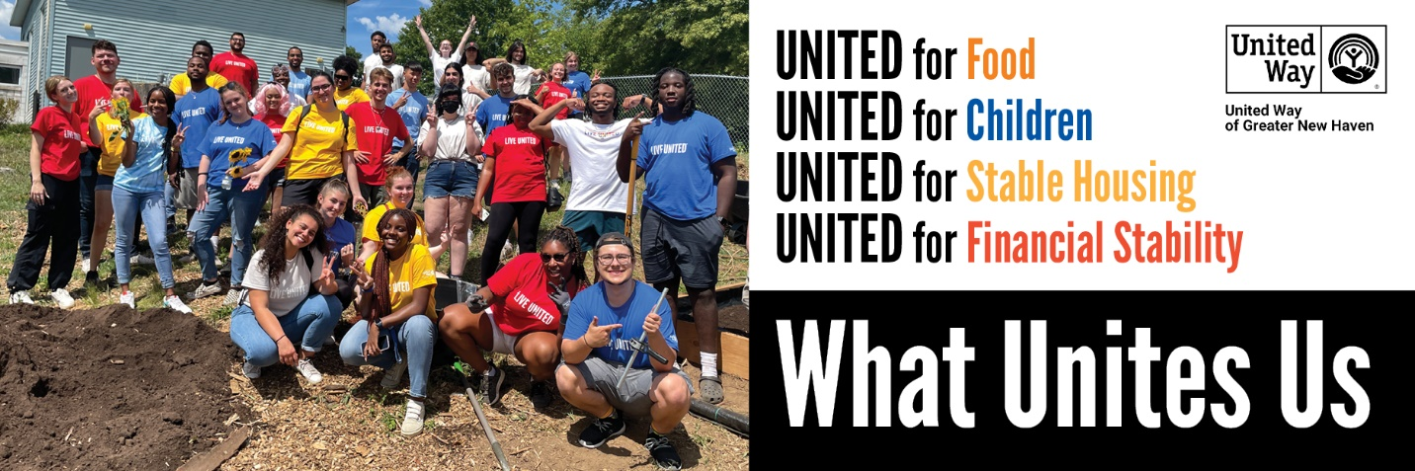

CAMPAIGN PREVIEW- SEND ONE WEEK BEFORE THE START OF THE CAMPAIGN

Subject Line: Get ready to put your values into action!
Preview Text: Together we can change lives.

Body Copy:

Dear Colleagues,

I’m excited to share that our annual United Way campaign is just around the corner! Our campaign will launch on <<date>> and we have set a goal this year to raise <<insert goal>>. I have every confidence that we can achieve our goal by uniting to put our values into action.

Your donation to United Way will be put to work meeting critical needs for children, parents, and neighbors in our community. Our campaign will support crucial work tackling the systemic roots of hunger, homelessness, and financial insecurity while working to help our neighbors meet their immediate needs.
Our past efforts have already made transformative changes in the lives of hundreds of thousands of people in our community. Donations of all sizes matter and will help our neighbors in need.

I’ll be sharing more in the weeks ahead about United Way’s life-changing work and how we can come together to invest in the future of our community.

If you have questions, please do not hesitate to reach out.

Thank you for Living United,
[YOUR NAME HERE]

P.S. See how you helped impact 106,129 lives in the 2021-2022 Impact Report!

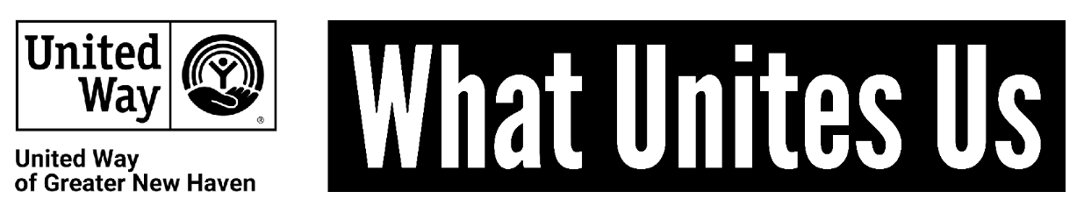

CAMPAIGN KICKOFF- SEND AT THE START OF THE CAMPAIGN

Subject Line: Let’s get UNITED! It’s time to help our neighbors

Body Copy:

Hello All,

<<Company’s>> United Way Campaign has officially launched! Now is the time to come together to put our values into action in our community. When we’re united for the causes that we care about, there’s nothing we can’t do!

Your donation makes a real difference for real families. Last year, our campaign helped United Way of Greater New Haven impact 106,129 local people through assistance in food, education, childcare, stable housing, advocacy for policy change, and more.

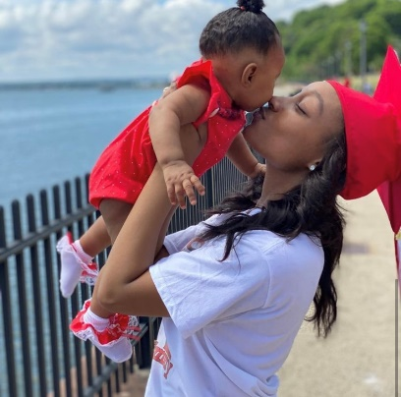
“Because of United Way donors, I was the first one in my family as a teen mom to graduate high school. They helped me get certifications as a CNA and a phlebotomist, and most importantly, my baby had a safe environment at Early Head Start where I could spend time with her between classes while finishing my degree. I plan to start college next fall to become a nurse. If it weren’t for United Way, our lives would have turned out completely differently.”
- Emerald and daughter Alayna, New Haven

At [COMPANY NAME HERE] we are committed to improving the quality of lives for people in our community. A donation to United Way changes lives for real local families like Emerald and Alayna.

Please consider participating [INSERT LINK]. There are many ways to give – one of the easiest is through payroll deduction, which allows you to give a little at a time. No gift is too small.
We’ve set a goal of raising [GOAL AMOUNT] and I know we can do it!

Thank you,
[YOUR NAME HERE]

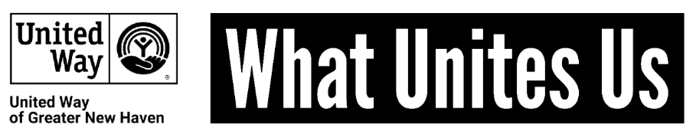

CAMPAIGN LAST PUSH

SEND TOWARD THE BEGINNING OF THE CAMPAIGN

Subject Line: There is still time to join!

Body Copy:

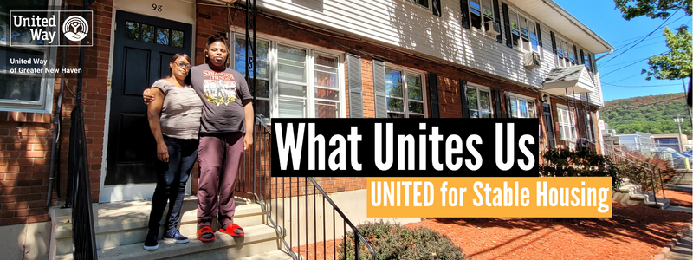

Because of donors like you, Andretia was able to find an apartment after losing her housing while her teenage son was fighting for his life while undergoing treatment for thyroid cancer.

“My son Elijah had thyroid cancer and was fighting for his life. It was the scariest moment of my life. Then on top of that, we had no place to stay. With United Way’s help, we were able to get a home. Which is what we needed more than anything at the time. If we didn’t get this apartment, we would have been living in a car. I don’t know what I would have done. Thank God for the United Way.”

Elijah is doing much better now and was able to graduate from high school despite his health challenges. With a stable place to call home, Andretia says her physical and mental health have improved drastically. She is now attending Gateway Community College and pursuing her dream of becoming an artist and art therapist. Because of donors like you, Andretia and Elijah have been able to grow and thrive with the stable foundation of secure housing.

Give now at [LINK] to help more local families access the resources they need to grow and thrive. You can make a world of difference for a child, parent, or neighbor.

CEO MESSAGE

SEND TOWARD THE BEGINNING OF THE CAMPAIGN

Subject Line: There is still time to join!

Body Copy:

"Alone We Can Do So Little. Together We Can Do So Much"
- Helen Keller

Good afternoon,

Our United Way campaign is the opportunity to come together to put our values into action in our community. Through our partnership, United Way of Greater New Haven was able to impact 106,129 lives last year. We know that our donations we are being invested in creating real and meaningful change for local children, parents, and neighbors.

When we join together, we tackle even the most difficult challenges. Will you join me in making a donation? When you give to United Way, whether it’s one dollar, or at the highest levels of the Leadership and Tocqueville Societies, you’re changing lives.

To give today, visit [INSERT LINK] or see [INSERT NAME] to make your donation.

Thank you in advance for your generosity.

Sincerely,
[CEO NAME]

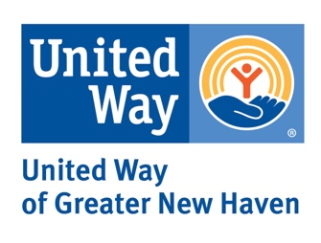

THANK YOU

SEND TO PEOPLE WHO HAVE MADE A GIFT

Subject Line: Thank You! Your gift changes lives
Preview Text: You help people like mom Emerald and her daughter Alayna

Body Copy:

Dear [NAME],

Thank you for participating in our United Way campaign and putting your values into action in our community. Your donation to United Way will be put to work meeting critical needs for children, parents, and neighbors in our community. You are offering people the resources they need to overcome obstacles and build a stronger future for themselves and their children.

“Anytime you want to achieve something, you have to surround yourself with people that care about you, that have your best interests at heart, who want to see you do well. You need positivity. United Way was that support network for me.”
- Emerald, Early Head Start mom and Workforce Alliance trainee

Thank you so much, not just from me or [COMPANY NAME], but from the countless lives you have impacted with your generosity.

Sincerely,
[YOUR NAME HERE]

